Software Engineering Spring 2016

Group #15

Parking Garage Automation

<http://www.galuwa.com>

Report 1

2/21/16

|  |  |
| --- | --- |
| Brandon Dunlap | brandon.dunlap@rutgers.edu |
| Vikram Krishna | vk235@rutgers.edu |
| Yufeng Liu | yufeng.liu@rutgers.edu |
| Luke Miller | luke.miller@rutgers.edu |
| Harshil Patel | harshil1029@gmail.com |
| Thomas Walters | twalters1012@gmail.com |
| Xiang Xing | xx52@scarletmail.rutgers.edu |

Table of Contents

Division of Labor: ………………………………... 3

Problem Statement: ………………………………... 3

Glossary of Terms: ………………………………... 7

Actors Available: ………………………………... 8

Stakeholders: ………………………………... 8

Actors and Goals: ………………………………... 8

Functional Requirements: ………………………………... 10

Non-Functional Requirements: ………………………………... 13

Use Cases: ………………………………... 14

Use Case Diagram: ………………………………... 16

Use Case Traceability Matrix: ………………………………... 17

Fully Dressed Description: ………………………………... 18

System Sequence Diagrams: ………………………………... 26

Domain Model: ………………………………... 29

Concept Definitions: ………………………………... 29

Association Definitions: ………………………………... 31

Attribute Definitions: ………………………………... 32

Concepts Traceability Matrix: ………………………………... 34

System Operational Contracts: ………………………………... 34

On Screen Appearance Requirements: ………………………………... 38

User Interface Specification: ………………………………... 46

User Effort Estimation: ………………………………... 53

Mathematical Model: ………………………………... 54

Project Management: ………………………………... 56

References: ………………………………... 61

**Division of Labor**

All team members contributed equally.

**Customer Statement of Requirements**

**Problem Statement**

Existing parking garage systems exhibit a plethora of flaws, including our current method of garage workers manually counting available parking spaces. Our current method makes optimization of garage usage incredibly difficult, while incurring unnecessary costs to the garage operator. Our manual system is also limited in it’s accuracy and resolution. The workers record the available spaces onto a spreadsheet, which is then manually entered into our database. A process which is not only slow, but very prone to human error. Spot identifying workers can only examine the garage so often, and can’t update the system immediately as cars come and go. The information we do have is typically not even available for customer use.

Parking should be a stress free, conveniently provided service, but do to the lack of information, drivers that arrive at the garage are subject to confusion and frustration. Unsure of available parking spaces, customers spend excess time searching for a park. The inconvenience can easily turn into frustration, which can lead to loss of customers. The absence of assigned spaces not only facilitates poor usage optimization, but an aggressive environment within the parking garage as customers are forced to compete for spaces. This issue is common among parking garages, and it forces customers to arrive and claim spaces hours before it should be necessary, for fear they will not find a spot if they do not take initiative. And the customers that don’t come early, and are not lucky, are forced to drive around and congest the garage in search of vacancies.

Current parking garage implementations do not satisfy the needs of those who need regularly scheduled parking spaces. Many garages will sell monthly passes, but without a computerized scheduler they risk overbooking and incorrectly estimating the number of cars present. Most monthly passes do not guarantee the availability of a spot, but instead allow the user to park whenever they’d like since they have already paid. The majority of parking garages also utilize a ticketing system that stamps arrival time and requests appropriate payment on garage exit. This does provide flexibility for the user to stay as long as they need, but can cause long payment lines and makes it impossible for management to monitor how long cars will stay. In the case of a lost ticket, drivers are typically charged for a full 24 hour period. While this benefits the management, customers are unhappy about being responsible for a small slip of paper. Many garages require payment prior to exit which forces the customer to seek out a ticket machine, which is often at a different entrance and has a large line. These machines do not accept PayPal, Android Pay, Apple Pay or any online payment processors.

These issues can be resolved by a centralized computer system that autonomously manages most aspects of user and administrative tasks. Manual spot availability checks can be readily replaced by a series of sensors that identify the presence of a car in every single parking spot. When a customer leaves or arrives, the status of this parking spot will immediately change in the system and be conveyed the customer. This availability can be displayed on a sign outside the garage in addition to the company website. This eliminates the issue of low checking resolution in addition to poor statistics monitoring for the administration. These spot indicators will eliminate the costs incurred by hiring additional spot checking employees and will be a more accurate representation of parking availability within the garage. In addition to actively monitoring occupied location, a centralized computer system would allow the garage to track when vehicles enter and exit, reinforcing availability checks.

The garage needs to be split into two sections. The upper deck will be designated parking for reservation and account holders only. The bottom deck will will behave as a traditional parking garage to facilitate walk-ins who do not wish to create an account with the garage. Availability for this deck is first come, first serve and there will be no guarantee for spot vacancy. The upper deck will be accessible only by a single car elevator and will be departed by a one way exit ramp. The upper deck can be accessed on foot by a stairwell or customer elevator that will require reservation confirmation to enter. The single car elevator will remove congestion inside the garage and restrain any waiting times to outside the parking garage. Wait times will be significantly diminished as a result of the reservation scheduling. There will not be more cars waiting in line than spots available in the garage.

Reservations can eliminate driver frustration within the garage by removing the need to search for a parking spot. Reserving a parking location during a designated period prior to arrival will guarantee the availability of the spot. Parking garage users will be able to create an account online containing payment method, demographic location and license plate information if available. Each account will have the ability to add multiple vehicles, but only business accounts will allow multiple drivers and multiple vehicles. Users of both personal and business accounts will have the ability to log into the company website on their laptop or mobile devices to view/edit their account information and make/manage reservations. Reservations do not require the entry of vehicle license plate information to accommodate those renting or borrowing vehicles. Reservations can be made at any point in advance and require the user to specify the arrival and departure time in increments defined by a specific garage. The user has the opportunity to extend their reservation up until the end of their existing reservation but the extension will be limited to a period defined by the garage. All extensions will be initiated through the user’s account on the company website. If the user exceeds their reservation, they will be charged a premium rate as defined by the garage. When the user exits the garage, their account will be billed. The user will have the ability to cancel a reservation for a garage specified period before their start time. After that period ends, their payment method will be charged whether or not they show up for their reservation. Though the user is encouraged to arrive at their designated time, there will be an arrival grace period as specified by garage management.

This automatic payment system eliminates the need for a driver to carry around any additional information. With the ability to check their active reservation and remaining time in their account, the stress of parking is no longer an issue. Customers who require regular parking will have the ability to purchase contracted reservations. Customers will have the ability to specify a weekly schedule and the parking times needed. This can be modified to occur at biweekly intervals or on set days every month. By default these reservations will be billed in total at the beginning of every month, but the garage management can modify this period in their account settings. Any overages for a contracted reservation will also be billed at the time of departure. At the time of reservation, a user will be notified of any premium or discounted fees during their stay. The user will also be aware of any additional fees through a cost estimator when their reservation is scheduled.

Automation will play a crucial role in enhancing user experience in, and outside the parking garage. Upon arrival, the driver’s licence plate will be scanned in the elevator and the reservation will be confirmed. If the driver was unable to register the vehicle’s license at the time of registration, a confirmation number can be manually entered or a QR code can be scanned to gain access. Users without a reservation will be directed to leave and valid customers will be transported to the correct floor and directed to a particular parking spot. Customers will exit the garage through a separate elevator or stairway and upon their return, will enter their confirmation number or scan their QR code to gain access to the garage’s upper deck. As they exit, a user’s license plate will be scanned and close their active reservation.

An important focus will be the security of the parking garage, the parking garage manager will be able to quickly access any cars within the garage for medical, law enforcement. A problem with current parking garages, is there are no security measures and quick access. Parking spots will be associated with license plates, and model of the car which will allow for quick lookup for any cars suspected for crimes for example. Not to mention, medical responders will be able to quickly find those in need of attention regardless of location in the parking garage, as internal cameras will be linked with alerts to emergency responders.These emergency responders may also alert government officials in accordance with a contractual agreement with our company which will provide benefits to both us and the government.

**Glossary of Terms**

* **Elevator Camera**: Scans license plate to confirm reservation
* **Garage Elevator**: Used to transport the customer’s vehicle to the designated floor
* **Exit Camera**: Scans license plates as cars leave
* **Elevator Console**: Allows user to access reservation by confirmation number
* **Elevator Display**: Displays registration information, the spot number which assigned to them and issues
* **QRCode Scanner**: Allows user to access reservation with confirmation QRCode
* **Occupancy Photosensor**: Photosensor on each parking spot for detecting car presence
* **Digital Display**: Mounted out front to represent vacancy
* **Closed Circuit Television Cameras**: Monitor crime and activity in garage
* **Confirmed Reservations**: Reservation created online by the customer
* **Guaranteed Reservations**: Subscribed reservations occurring regularly
* **Understays**: Customers who leave before they time has expired
* **Overstays**: Customers who exceed their reserved time
* **Overstay Surcharge**: An increased rate charged to customers for exceeded time
* **Walk-Ins**: Customers who do not reserve a spot prior to entering the parking garage
* **Cancellation**: A request sent in by the customer at least 24 hours prior to the time slot to cancel their reservation
* **Cancellation Fee**: A fee charged to a customer who requests a cancellation within less than 24 hours of their start time
* **Check-In**: When a customer uses their QRCode/confirmation number at the console
* **Web User Account**: An account for the customer used for general account management purposes and to modify payment/vehicle information and reservations/cancellations
* **Occupancy Checks**: Current implementation to manually check for vacant/occupied spots vs the new idea of automated checks by the system
* **Occupancy Forecast**: Projections on availability of spaces based on usage history
* **Specials**: Price cuts, or discounts, applied during promotion periods
* **Holiday Hours**: Specific hours of operation during holidays
* **Grace Period**: A certain amount of time given to the customer to enter/leave his spot

**System Requirements**

**Actors Available**

* Parking Garage Manager; ST-M#
* Vehicle Operator (Customer); ST-C#
* Emergency Response Team; ST-ER#
* Parking Garage Owner; ST-GO#
* Payment Processing Company; ST-P#
* Business Account Manager (Business Customer); ST-BC#

Note: Business customers are a child of customers. All customer requirements apply to business customers but not the other way around.

**Stakeholders**

* Parking Garage Manager; ST-M#
* Vehicle Operator (Customer); ST-C#
* Emergency Response Team; ST-ER#
* Parking Garage Owner; ST-GO#
* Payment Processing Company; ST-P#
* Business Account Manager (Business Customer); ST-BC#

**Actors and Goals**

*Parking Garage Manager:* (Initiating Actor) The role of the parking garage manager is to implement policies utilized by the customers. These responsibilities include but aren’t limited to: setting prices, establishing days & hours of operation and setting a reservation grace period. The goal of the parking garage manager is to satisfy all customers and optimize garage usage and profits.

*Vehicle Operator- Customer (Initiating Actor)* The role of the vehicle operator is to utilize available features of the garage to occupy a parking space during a set period of time. The goal of the Customer is to access convenient and headache free parking.

*Emergency Response Team (Participating Actor)* The role of the emergency response team is to respond to emergencies such as a fire, electrical outages, safety issues with the users, and watch over security camera feedback. The goal of the Emergency Response Team is to ensure that no users of the system experience danger or injuries while using the garage.

*Parking Garage Owner (*Initiating Actor) The role of the parking garage owner is to oversee the manager and make high-level administrative decisions for his investment. The goal of the parking garage owner is to maximize profits.

*Payment Processing Company (Participating Actor)* The role of the payment processing company is to process the payments made by users through credit cards and other “virtual” payment methods. They will be given a fee for this service. The goal of the Payment Processing Company is to maximize profits and ensure the safe transfer of funds between the user and the garage.

*Business Account Manager (Initiating Actor)* The business account manager is essentially a business customer. This person’s role is to use the account given by his business to make multiple vehicle/person reservations for parking spaces when needed. The goal of the business account manager is to efficiently manage multiple drivers and vehicles within their business account.

*Plate Scanner (Participating Actor):* The role of the plate scanner is to scan the user’s license plate number and transfer it to the elevator console. The goal of the plate scanner is to correctly interpret the license plate number and relay the information to the centralized server for efficient processing.

*Elevator Console (Participating Actor):* The role of the elevator console is to check if the information given by customer matches the data saving in their account. This information will come in the form of a reservation confirmation number when the customer’s licence plate is not on file. The goal of the Elevator Console is to provide a mechanism through which a customer can still access the garage without having registered their license plate previously.

*Occupancy Photosensor (Participating Actor):* The role of the occupancy photosensor is to check if the parking spot is occupied or vacancy. The goal of the Occupancy Photosensor is to relay the status of every parking spot to the centralized computer system.

*Garage Website (Participating Actor) :* The role of the website is to provide a platform which allows customers to make the reservations and edit their personal information. In addition, the garage managers could check the garage statics and receive important messages about garage within their accounts. The goal of the website is to tie together all aspects of the parking garage into a cohesive user experience.

*Garage Console (Participating Actor) :* The role of the garage console is to compute and charge the parking fee when customer leaves the garage. The goal of the Garage Console is to fetch current pricing schemes and elapsed time from the centralized server when a user leaves the garage. The user will be billed appropriately.

**Functional Requirements**

|  |  |  |
| --- | --- | --- |
| Identifier | Priority Weight | User Story |
| ST-C1 | 5 | As a customer I want to log into my account and make a single use reservation. |
| ST-C2 | 5 | As a customer I want to cancel reservations during a garage specified period before the reservation start time. |
| ST-C3 | 5 | As a customer I want to add, edit, or delete payment information. |
| ST-C4 | 5 | As a customer I want to enter my confirmation number or scan my QRCode if my license plate is not registered. |
| ST-C5 | 4 | As a customer I want a grace period on reservation arrival. |
| ST-C6 | 3 | As a customer I want the elevator display to show me the location of my spot. |
| ST-C7 | 3 | As a customer I want to be notified of holiday operating hours. |
| ST-C8 | 2 | As a customer I want the website to display promotional offers or discounts, if any are available at the time. |
| ST-C9 | 2 | As a customer I want to receive a reminder by SMS or e-mail when my reservation time is approaching. |
| ST-C10 | 4 | As a customer I want a confirmation after I make a reservation. |
| ST-C11 | 5 | As a customer, I want to seamlessly overstay my reservation at a surcharged rate. |
| ST-C12 | 5 | As a customer, I want to park my car without a reservation, if space is available, in the “walk-in” area. |
| ST-C13 | 3 | As a customer, I want to be notified if I try to make a reservation with an expired payment method. |
| ST-C14 | 5 | As a customer, I want to add, edit, or delete vehicle information from my account settings. |
| ST-C15 | 4 | As a customer, I want there to be step-by-step instructions on what to do as I enter the garage |
| ST-C16 | 5 | As a customer, I want a guaranteed spot or an overbooking compensation if I make a reservation. |
| ST-C17 | 5 | As a customer, I want to log into my account and schedule a recurring parking reservation. |
| ST-C18 | 4 | As a customer, I want the option to park after my reservation grace period if vacancies are available. |
| ST-C19 | 3 | As a customer, I want to be granted garage access 5 minutes prior to my reservation if vacancy exists. |
| ST-C20 | 3 | As a customer, I want to provide my feedback through my account. |
| ST-C21 | 2 | As a customer, I want to make a reservation for my friend or family member. |
| ST-C22 | 5 | As a customer, I want to create a new account if I have not yet registered. |
| ST-C23 | 3 | As a customer, I want to reset my password through email if I cannot log in. |
| ST-C24 | 3 | As a customer, I want to see other users’ feedbacks and have the option to agree or disagree with them. |
| ST-M1 | 2 | As a manager, I want to identify and locate any cars for emergency reasons and make necessary reservation adjustments. |
| ST-M2 | 4 | As a manager, I want to specify the time increment for reservation scheduling. |
| ST-M3 | 5 | As a manager, I want to set the hourly parking rate through my account settings. |
| ST-M4 | 3 | As a manager, I want to associate special rates with specific hours or days. |
| ST-M5 | 3 | As a manager, I want to set an overstay rate through my account settings. |
| ST-M6 | 4 | As a manager, I want to receive emergency reports from an emergency response team if there are any emergencies. |
| ST-M7 | 2 | As a manager, I want to receive an alert if an unauthorized car shows up in the garage. |
| ST-M8 | 3 | As a manager, I want to receive a photo of the car before it enters the garage. |
| ST-M9 | 3 | As a manager, I want to receive a highlighted feedbacks list every week. |
| ST-BC1 | 4 | As a business customer, I want to manage driver identities and login permissions associated with my business. |
| ST-BC2 | 3 | As a business customer, I want to allow multiple drivers to view but not edit or create reservations. |
| ST-BC3 | 3 | As a business customer, I want to make a group reservation through single account. |
| ST-ER1 | 1 | As an emergency response team, I want to be immediately notified of a fire, unauthorized access or violence. |
| ST-ER2 | 3 | As an emergency response team, I want to be notified of malfunctions of devices and equipments. |
| ST-GO1 | 3 | As the parking garage owner, I want to check out the monthly customer flow and total revenue. |
| ST-GO2 | 3 | As a parking garage owner, I want to be notified the reasons and results of unexpected cost, for instance, fire, car scratch. |
| ST-P | 4 | As the payment processing agent, I want to get the detail of essential history information, including daily rate, customer information and parking time. |

**Non-Functional Requirements**

|  |  |  |
| --- | --- | --- |
| Identifier | Priority Weight | Requirement |
| ST-NF1 | 5 | The active number of cars in the garage will be monitored by entry and exit plate scanners. |
| ST-NF2 | 5 | The presence of a vehicle in each spot will be monitored by photo-sensors in each parking spot. |
| ST-NF3 | 5 | The online scheduling software will only display available parking spots in addition to an allowed tolerance of overbooked spots. |
| ST-NF4 | 4 | The online scheduling software will automatically adjust the reservation cost based upon any premiums and discounts at that time. |
| ST-NF5 | 3 | The online scheduling software will automatically reduce the reservation limitation during holidays. |
| ST-NF6 | 5 | Upon departure, a user’s payment method will be billed accordingly. |
| ST-NF7 | 3 | If requested by the customer, notifications will be sent a set period prior to reservation start and end time. |
| ST-NF8 | 5 | Management specification rules including hourly rate, overstay premium, special pricing and grace period will seamlessly factor into the customer’s cost. |
| ST-NF9 | 4 | The information of the vehicle should be checked, including owner’s name, make, model, color, and car accident history |
| ST-NF10 | 3 | If requested by the customers, notifications about changing of operating hours will be sent to them by SMS or e-mail. |
| ST-NF11 | 3 | The license plate numbers of the cars parked in the garage will be automatically matched with their parking spot numbers. |
| ST-NF12 | 2 | If customers choose to use QR code, the system will automatically recognize the QR code they provide. |
| ST-NF13 | 5 | The garage will have internal cameras linked with servers to provide information about the security of the garage |

**Use Cases**

*Casual Descriptions:*

UC-1:Registration - User A wishes to create a user account through the garage website. User A provides his/her personal information on the login page of [www.galuwa.com](http://www.galuwa.com). After server confirmation, he/she can log in using their email and password. The user can then configure vehicle and payment information from the quick links available on their account home page.

[C1, C3, C7, C9, C14, C20, C22, C23, C24, BC1]

UC-2:Reservation - User A wishes to make a single or contracted reservation through the garage website. User A can log in to their user account and create a reservation through the quick links on their home page. User A will receive a confirmation from the website.

[C1, C2, C10, C13, C16, C17, C21, BC2, BC3]

UC-3:Parking - User A has arrived the parking garage and wishes to parks his vehicle into the garage. User A has to provide a QR code or confirmation number to get the access to elevator.

[C4, C5, C6, C12, C15, C19, ER1, ER2]

UC-4:Overstay - User A overstays his reservation and did not make an extension. User A have to pays a surcharged rate due to the parking policy when he leaves. User A will receive a confirmation email later.

[C11, C18, M5]

UC-5:Understay - User A has made his reservation online and arrive on time. User A now has to leave earlier and the spot is left to be vacant. User A will be charged at full price and has no more access to the spot.

[C1, C5, C6, C11]

UC-6:Departure - User A exits the garage on time.User A ‘s payment method will be automatically charged when the exit camera detects his leaving. User A will receive his receipt through email later.

[C11, P]

UC-7:Policy Decision - Manager B logs into the garage administrative panel to set hourly rates and this month’s specials

[C7, C8, C16, C17, C18, M1, M2, M3, M4, M5, M6, M7, M8, M9, GO1, GO2, P]

**Use Case Diagram**

**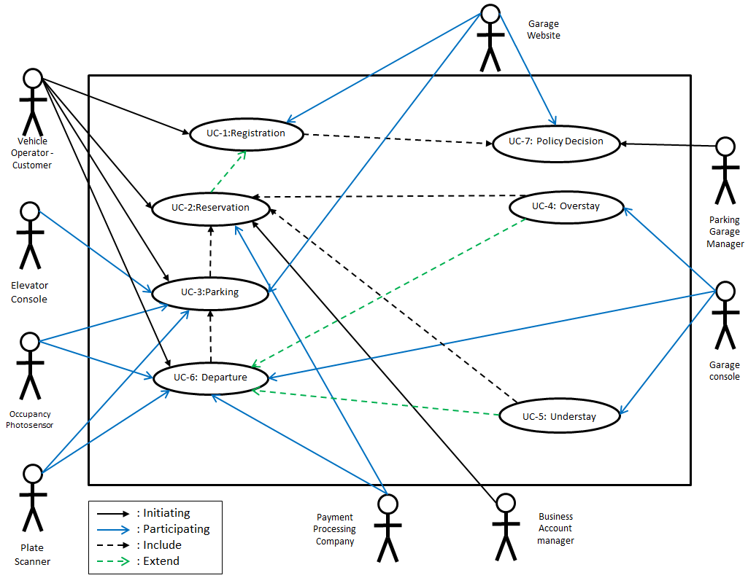**

This Use Case diagram displays interaction between our actors and Use Cases within the system. This also highlights how Use Cases interact with one another.

**Use Case Traceability Matrix**

|  |  |  |  |  |  |  |  |  |
| --- | --- | --- | --- | --- | --- | --- | --- | --- |
| **Requirements** | **Priority Weight** | **UC-1** | **UC-2** | **UC-3** | **UC-4** | **UC-5** | **UC-6** | **UC-7** |
| **ST-C1** | **5** | **x** | **x** |  |  | **x** |  |  |
| **ST-C2** | **5** |  | **x** |  |  |  |  |  |
| **ST-C3** | **5** | **x** |  |  |  |  |  |  |
| **ST-C4** | **5** |  |  | **x** |  |  |  |  |
| **ST-C5** | **4** |  |  | **x** |  | **x** |  |  |
| **ST-C6** | **3** |  |  | **x** |  | **x** |  |  |
| **ST-C7** | **3** | **x** |  |  |  |  |  | **x** |
| **ST-C8** | **2** |  |  |  |  |  |  | **x** |
| **ST-C9** | **2** | **x** |  |  |  |  |  |  |
| **ST-C10** | **4** |  | **x** |  |  |  |  |  |
| **ST-C11** | **5** |  |  |  | **x** | **x** | **x** |  |
| **ST-C12** | **5** |  |  | **x** |  |  |  |  |
| **ST-C13** | **3** |  | **x** |  |  |  |  |  |
| **ST-C14** | **5** | **x** |  |  |  |  |  |  |
| **ST-C15** | **4** |  |  | **x** |  |  |  |  |
| **ST-C16** | **5** |  | **x** |  |  |  |  | **x** |
| **ST-C17** | **5** |  | **x** |  |  |  |  | **x** |
| **ST-C18** | **4** |  |  |  | **x** |  |  | **x** |
| **ST-C19** | **3** |  |  | **x** |  |  |  |  |
| **ST-C20** | **3** | **x** |  |  |  |  |  |  |
| **ST-C21** | **2** |  | **x** |  |  |  |  |  |
| **ST-C22** | **5** | **x** |  |  |  |  |  |  |
| **ST-C23** | **3** | **x** |  |  |  |  |  |  |
| **ST-C24** | **3** | **x** |  |  |  |  |  |  |
| **ST-M1** | **2** |  |  |  |  |  |  | **x** |
| **ST-M2** | **4** |  |  |  |  |  |  | **x** |
| **ST-M3** | **5** |  |  |  |  |  |  | **x** |
| **ST-M4** | **3** |  |  |  |  |  |  | **x** |
| **ST-M5** | **3** |  |  |  | **x** |  |  | **x** |
| **ST-M6** | **4** |  |  |  |  |  |  | **x** |
| **ST-M7** | **2** |  |  |  |  |  |  | **x** |
| **ST-M8** | **3** |  |  |  |  |  |  | **x** |
| **ST-M9** | **3** |  |  |  |  |  |  | **x** |
| **ST-BC1** | **4** | **x** |  |  |  |  |  |  |
| **ST-BC2** | **3** |  | **x** |  |  |  |  |  |
| **ST-BC3** | **3** |  | **x** |  |  |  |  |  |
| **ST-ER1** | **1** |  |  | **x** |  |  |  |  |
| **ST-ER2** | **3** |  |  | **x** |  |  |  |  |
| **ST-GO1** | **3** |  |  |  |  |  |  | **x** |
| **ST-GO2** | **3** |  |  |  |  |  |  | **x** |
| **ST-P** | **4** |  |  |  |  |  | **x** | **x** |

**Fully Dressed Description**

|  |  |  |  |
| --- | --- | --- | --- |
| Use Case UC-1: | | | Registration |
| Related Requirements: | | | ST-C1, ST-C3, ST-C7, ST-C9, ST-C14, ST-C20, ST-C22  ST-C23, ST-C24, ST-BC1 |
| Initiating Actor: | | | Vehicle Operator - Customer, Business Account Manager |
| Actor’s Goal | | | To create a account on [www.galuwa.com](http://www.galuwa.com) which allows customer to make reservations and modify the personal and vehicle information. |
| Participating Actors: | | | Website Server |
| Preconditions: | | | Customers have to provide the authenticated information required by the garage website. |
| Postconditions: | | | Customer account information will be stored in the website database and can be modified by the customer at any time. |
| Flow of Events for main Success Scenario: | | | |
| → | 1 | The customer presses the “Don’t have an account” button on garage user login page. | |
| ← | 2 | The garage website displays a form for the customer to fill out. This form contains the First Name, Last Name, Email, Password, Password Confirmation, Zip-Code and Account Type fields. | |
| → | 3 | The customer fills out the required information and presses “Submit.” | |
| ← | 4 | The garage website verifies the information. This check ensures that the email does not already exist within the database of the users. The zip-code is also used to lookup local garages for the customer to use. | |
| ← | 5 | The garage website stores the customer’s information into a database and allows the customer to log in with the username and password. | |
| Flow of Events for Extensions (Alternate Scenarios): | | | |
| →  ← | 4A | If the email already exists in the database, the garage website highlights the invalid information and prompts the user to change it.  The customer can change the unverified information and resubmit the form. Proceed to Step 4. | |
| →← | 3A | If the password and password confirmation fields do not match, the user will be asked to retype both fields. | |

|  |  |  |  |
| --- | --- | --- | --- |
| Use Case UC-2: | | | Reservation |
| Related Requirements: | | | ST-C1, ST-C2, ST-C3, ST-C7, ST-C8, ST-C10, ST-C16, ST-C17, ST-C21, ST-BC2, ST-BC3 |
| Initiating Actor: | | | Vehicle Operator - Customer, Business Account Manager |
| Actor’s Goal | | | To make a reservation for a parking spot during an available time period. |
| Participating Actors: | | | Payment Processing Company, Garage Website |
| Preconditions: | | | Customers must have had to make an account on the website to be logged in. |
| Postconditions: | | | There will be an active reservation schedule accessible through the customer’s account |
| Flow of Events for main Success Scenario: | | | |
| → | 1 | The customer presses “New Reservation” link in his/her account home page. | |
| ← | 2 | The website displays the metadata associated with making a reservation such as the time and date. | |
| → | 3 | The customer chooses the time, reviews expected pricing, and presses “Submit.” | |
| ← | 4 | Garage website verifies the reservation information and uploads it to the server. | |
| → | 5 | The confirmation of the time and date are displayed to the user along with a QR code and confirmation number. | |

|  |
| --- |
| FlowChart for Alternative Scenarios |

|  |  |  |
| --- | --- | --- |
| →  ← | 4a | The customer tries to create a reservation that conflicts with their existing reservation. They will be shown an error and asked to try again. Proceed to step 2. |

|  |  |  |  |
| --- | --- | --- | --- |
| Use Case UC-3: | | | Parking |
| Related Requirements: | | | ST-C1, ST-C4, ST-C5, ST-C6, ST-C9 |
| Initiating Actor: | | | Vehicle Operator - Customer, Business Account Manager |
| Actor’s Goal | | | To park their vehicles in the garage, either by using their reservations or via the walk-in lots. |
| Participating Actors: | | | Plate Scanner, Elevator Console, Occupancy Photosensor. |
| Preconditions: | | | At least one spot must be available in either the reserved or walk-in lots. |
| Postconditions: | | | Photo-Sensors will report the presence of a vehicle in the spot assigned to the user. |
| Flow of Events for main Success Scenario: | | | |
| → | 1 | The customer drives into the elevator after arriving at the garage. | |
| ← | 2 | The plate scanner scans the license plate of the customer’s vehicle and transfers it to elevator console. | |
| ← | 3 | The elevator console confirms the customer’s information and selects a vacant parking spot for the user. | |
| ← | 4 | The elevator lifts the customer’s vehicle to the upper level and displays the user’s assigned parking space. | |
| → | 5 | Customer parks vehicle into assigned spot. | |
| ← | 6 | Occupancy photosensor detects customer vehicle has parked into the spot. | |
| Flow of Events for Extensions (Alternate Scenarios): | | | |
| →  ← | 2B | Elevator console can’t find the license plate in the database and asks the customer to provide the confirmation number/QR code.  Customer provides his confirmation number/QR code (If it’s right, move to 3. If not move to 2C). | |
| →  ← | 2C | Elevator console can’t find the confirmation number/QR code in the database and asks customer to leave or drive to the walk-in area.  Customer chooses leave or drives to the walk-in area. | |
| →← | 3A | Despite customer reservation, the garage is overbooked and no vacant spots are available for the customer. The customer will be given a refund and an additional discount coupon decided upon by management. | |

|  |  |  |  |
| --- | --- | --- | --- |
| Use Case UC-4: | | | Overstay |
| Related Requirements: | | | ST-C11, ST-C18, ST-M5 |
| Initiating Actor: | | | Garage Console. |
| Actor’s Goal | | | To seamlessly overstay their allotted reservation time. |
| Participating Actors: | | | Occupancy Photosensor, Parking Garage Manager,Vehicle Operator - Customer |
| Preconditions: | | | The customer’s parking exceeds the reserved time. |
| Postconditions: | | | The customer pays a surcharged rate for additional stay when leaving the garage. |
| Flow of Events for main Success Scenario: | | | |
| → | 1 | The garage console flags the overstayed vehicle and marks it within the database. | |
| ← | 2 | The system will automatically adjust and recalculate all vacant spaces. | |
| ← | 3 | The customer is notified that his vehicle is an overstay and the details about the overstay policy including pricing. | |
| Flow of Events for Extensions (Alternate Scenarios): | | | |
| → | 4 | If the customer’s vehicle is not retrieved in a set amount of time specified by the administration, a towing company will be called. | |

|  |  |  |  |
| --- | --- | --- | --- |
| Use Case UC-5: | | | Understay (Normal Usage) |
| Related Requirements: | | | N/A |
| Initiating Actor: | | | Vehicle Operator - Customer |
| Actor’s Goal | | | This is normal operating procedure for a vehicle operator. |
| Participating Actors: | | | Payment Processing Company, Plate Scanner, Garage Console. |
| Preconditions: | | | The customer leaves on time or prior to the end of their reservation. This frees a parking spot. |
| Postconditions: | | | Once the customer leaves the parking garage their reservation is complete and will have to make a new reservation if they wish to re-enter the garage |
| Flow of Events for main Success Scenario: | | | |
| → | 1 | Customer leaves the garage on time or earlier than his/her scheduled departure. | |
| ← | 2 | The Occupancy Photosensor detects the vacant parking spot and signals the system and a customer is leaving. | |
| ← | 3 | The Exit Plate scanner detects the departure of the customer and send notifies the central system. | |
| ← | 4 | The Garage console marks this reservation as “completed” and updates the database. | |
| → | 5 | The customer receives an email/SMS thanking them for their service and requesting feedback. | |
| Flow of Events for Extensions (Alternate Scenarios): | | | |
|  |  |  | |

|  |  |  |  |
| --- | --- | --- | --- |
| Use Case UC-6: | | | Departure |
| Related Requirements: | | | ST-C11 |
| Initiating Actor: | | | Vehicle Operator - Customer |
| Actor’s Goal | | | To leave the garage and pay the parking fee. |
| Participating Actors: | | | Payment Processing Company, Plate Scanner, Garage Console, Occupancy Photosensor. |
| Preconditions: | | | Customers is at the exit of the garage. |
| Postconditions: | | | The system is updated to reflect the change in active reservations. |
| Flow of Events for main Success Scenario: | | | |
| → | 1 | The customer’s vehicle arrives to the garage exit. | |
| ← | 2 | The plate scanner scans the license plate number of the arriving vehicle and identifies the user. | |
| ← | 3 | The garage console charges the appropriate fee based on the parking time and rate set by the garage manager. Overstays will be factored into the price. | |
| → | 4 | Customer’s selected payment method will be charged automatically with the Payment Processing Company’s assistance. | |
| → | 5 | A email notification will be sent to both customer. | |
| Flow of Events for Extensions (Alternate Scenarios): | | | |
| →  ← | 1 | The customer overstays his reservation. The system will adjust for vacant spaces and flag the user’s reservation with overstay pricing. Proceed to step 4. | |

|  |  |  |  |
| --- | --- | --- | --- |
| Use Case UC-7: | | | Policy Decision |
| Related Requirements: | | | ST-C7, ST-C8, ST-C16, ST-C17, ST-C18, ST-M1, ST-M2, ST-M3, ST-M4, ST-M5, ST-M6, ST-M7, ST-M8, ST-M9, ST-P, ST-GO1, ST-GO2 |
| Initiating Actor: | | | Parking Garage Manager |
| Actor’s Goal | | | To set parking rates, promotional offers or any policies which are related to garage. |
| Participating Actors: | | | Garage Website |
| Preconditions: | | | The parking garage manager is logged in to their account. |
| Postconditions: | | | The system reflects the manager’s changes. |
| Flow of Events for main Success Scenario: | | | |
| → | 1 | The parking garage manager logs into his/her account and accesses the “Rates” or “Settings” panel. | |
| → | 2 | The garage manager is able to view existing policies in addition to editing, deleting, and creating new ones. | |
| → | 3 | The new policies are verified by the server and are uploaded. All changes are reflected on the website. Existing reservations will not be affected by price changes. | |
| → | 4 | Any contracted reservation customers are notified by email or SMS of the new rates and will be subject to them starting the next billing period. | |
| Flow of Events for Extensions (Alternate Scenarios): | | | |
| →← | 1 | New policy conflicts with an existing policy. The manager will be notified of the conflicting rules and asked if the old rule should be overwritten. Proceed to step 3. | |

**System Sequence Diagrams**

**UC-1 Registration:**

**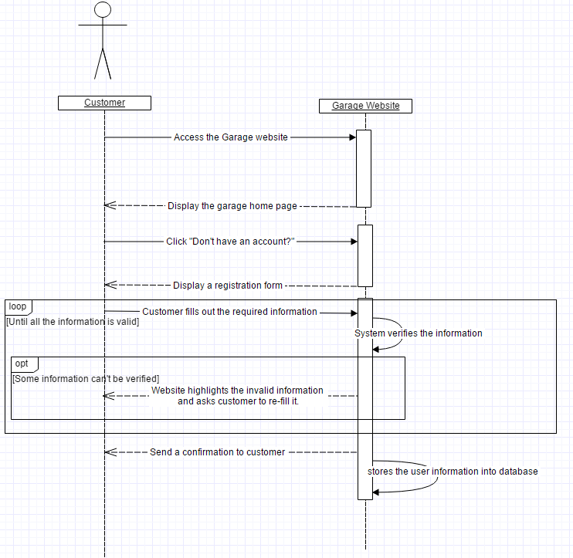**

System Sequence diagram(Registration) reveals the interactions betweencustomers and garage website in the registration process.

**UC-2 Reservation:**

**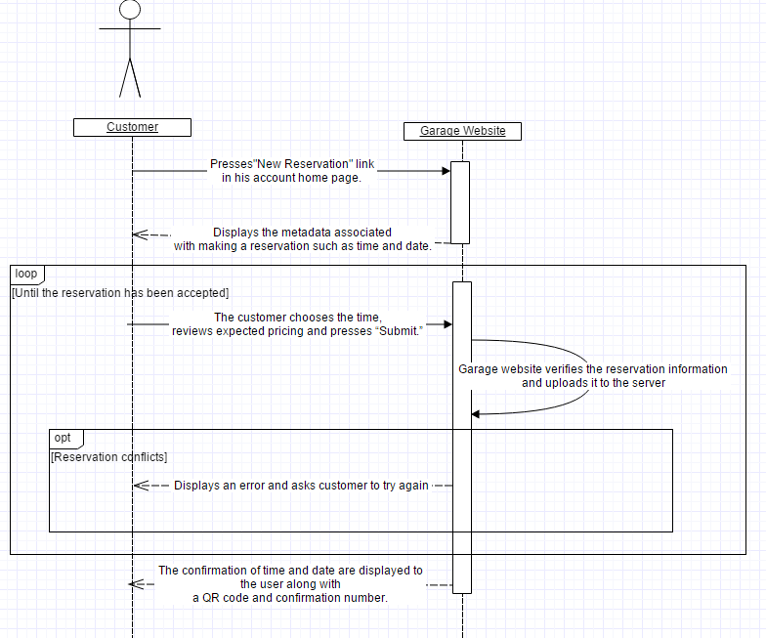**

System Sequence diagram(Reservation) reveals the interactions betweencustomers and garage website in the reservation process.

**UC-3 Parking:**

**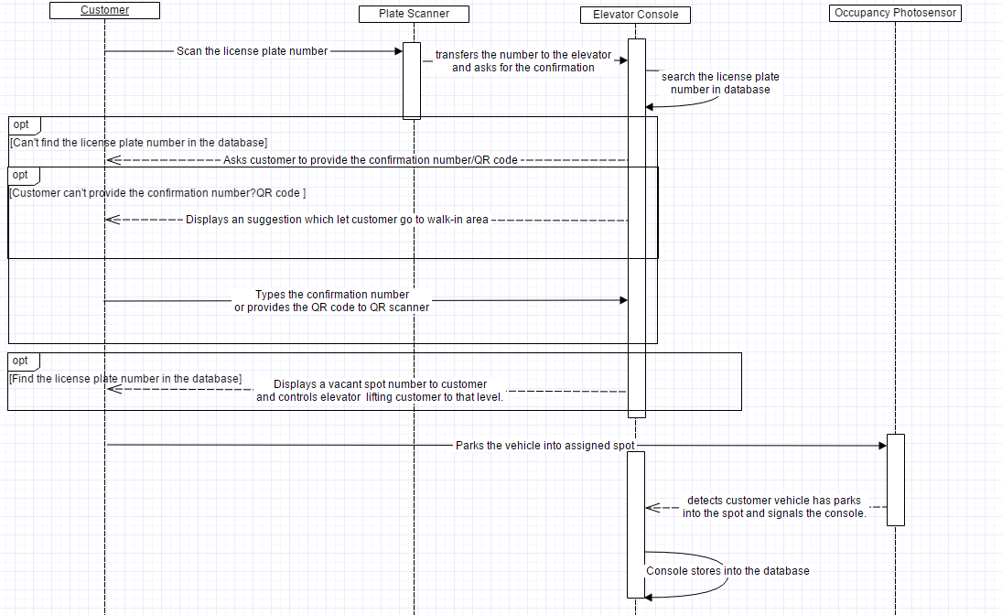**

System Sequence diagram(Parking) reveals the interactions betweencustomers and multiple garage devices under different conditions in the parking process.

**Domain Model**

Untitled Diagram (2).png

This Domain Model shows the interaction of System Concepts. This Diagram serves as a general flowchart through the computer portion of our system.

**Concept Definitions**

(D=Doing; K=Knowing; N=Neither)

|  |  |  |
| --- | --- | --- |
| Responsibility | Type | Concept |
| User creates account and inputs all of his/her personal information. | N | User Interface |
| User can create reservation using their account on the website | K | User Interface |
| User provides QR code in order to be able to access elevator | , | Elevator Interface |
| Used to show parking, current rate, and availability to cars on the street outside the lot | D | Outdoor Display |
| Manages parking rates, promotional offers, and any policies related to the garage | D | Manager Interface(Instance of User Interface) |
| Manages all employee information | D | Manager Interface(Instance of User Interface) |
| Keeps track of and notifies Controller of all overstay ]vehicles | D | Parking Database |
| Keeps track of and notifies Controller of any vehicles that leave on time opening up spots | D | Parking Database |
| Allows users to create a reservation at the garage if they do not already have one | D | Walk-in Customer Interface(Instance of User Interface) |
| Reads the license plate of incoming cars, and out going and checks with the reservation/parking database | D | License Plate Reader |
| Houses all active reservations. The Controller checks with the reservation database when a new reservation is requested. | D | Reservation Database |
| Senses the arrival or departure of a car at a specific parking spot. | D | Occupancy Photosensor |
| Communicates with other components of the system. The Controller calculates usages and available parking. | D | Controller |

**Association Definitions**

|  |  |  |
| --- | --- | --- |
| Concept Pair | Association Definition | Association Name |
| User Interface and Controller | User passes information through an interface(app, website, etc.). The information ranges from account info to making a reservation | Passes information |
| Controller and Parking Database | Controller sends information to Parking Database, for a walk-in spot | Parking Database Updated |
| Controller and Reservation Database | Controller sends information to the reservation database, for a pre-scheduled reservation | Reservation Database Updated |
| License Plate Reader and Controller | License Plate Reader sends information whether a car is leaving or entering the garage | Conveys Information |
| Manager Interface and Controller | Manager changes the current rates, sets promotions, etc. This information is passed to controller | Conveys Managerial Information |
| Controller and Outdoor sign | Controller passes any information regarding deals, daily cost, # of spots open, etc. to the outdoor sign | Conveys Business Information |
| Controller and Occupancy Sensor | Sensor passes information to the Controller when a car enters a spot and leaves the spot, but not the garage. | Conveys State of Parking Spot information |
|  |  |  |

**Attribute Definitions**

|  |  |  |
| --- | --- | --- |
| Concept | Attributes | Definition |
| Database | UserInfo | Contains the user information such as payment information, vehicle information, personal preferences. |
| ReservationList | Website will transfer the reservation information to the database. |
| WalkInList | Stores the Walk-In Vehicle information. |
| ParkingList | Stores the information of the vehicles which are parking in the garage.(spot number, license plate number, customer’s information) |
| OverstayList | When system detects the overstay vehicles, those vehicles will be flagged in the database. |
| StatisticsData | The statistics data which could be accessed by manager. |
| User Interface | UserLogin | Registered Customers use their account name and password to log in the garage website. |
| CreateRegistration | Registered Customers create their reservation. |
| Cancel/Edit Registration | Registered Customers are allowed to change and cancel their existed Registration information. |
| EditPayment | Registered Customers could edit their credit cards information. |
| EditVehicle | Registered Customers could edit and add vehicles in their account. |
| PersonalPreference | Registered Customers could choose if they want to receive the email/SMS from Website. |
| ManageParkingRate | Manager is allowed to edit the parking rate. |
| PolicyMake | Manager can edit the parking garage’s policy, for instance, special deals, overstay rate etc. |
| StatisticsCheck | Manager could get the statistics chart of the parking garage. (revenue, cost) |
| License Plate Reader | GetPlateNumber | Automatically get customers’ plate numbers when they drive into elevator. |
| SignalSys | After read the plate number, license plate reader will transfer the number to system. |
| EnterDetect | Detect the entering vehicle and singal the system. |
| ExitDetect&Charge | Detect the leaving vehicle and singal the system to charge. |
| Elevator  Interface | AsktoType | If the customer’s plate number is not stored in the system, console will ask customer to type the confirmation number. |
| QRScan | If customer choose to provide the QR code, console will scan it instead of confirmation number. |
| SignalElevator | Complete the confirmation, elevator console will signal the elevator to lift customer to specified level. |
| SignalDisplay | Elevator console will signal the elevator display and let it show the reservation information. |
| Occupancy Photosensor | SpotVacant | Photosensor will detect If the spot becomes vacant and signal the system. |
| SpotOccupied | Photosensor will detect if the spot becomes occupied and signal the system. |

**Concepts Traceability Matrix**

|  |  |  |  |  |  |
| --- | --- | --- | --- | --- | --- |
|  | **Domain Concepts** | Website | Parking  Interface | Outdoor  Sign | Parking  Database |
| **Use Cases** |  |  |  |  |  |
| UC-1  (Registration) |  | **X** |  |  |  |
| UC-2  (Reservation) |  | **X** | **X** |  | **X** |
| UC-3  (Parking) |  |  | **X** | **X** | **X** |
| UC-4  (Overstay) |  |  | **X** | **X** | **X** |
| UC-5  (Understay) |  |  | **X** | **X** | **X** |
| UC-6  (Departure) |  |  |  |  | **X** |
| UC-7  (Policy Decision) | **X** | **X** |  | **X** |  |

**System Operational Contracts**

|  |  |
| --- | --- |
| **Operation** | Registration |
| **Class Invariants** | The user requires access to an account on www.galuwa.com. |
| **Preconditions** | * The user must not yet have a registered account on galuwa.com. * The user must fill in the necessary fields on the registration form. * Must enter a valid e-mail address. * Must enter a password between 8-12 characters(no punctuation/symbols). |
| **Postconditions** | * An account is created for the user and this information is stored in the database. * The user is directed to the home page of his account with a welcome message. |

|  |  |
| --- | --- |
| **Operation** | Reservation |
| **Class Invariants** | The user must be registered and logged in. |
| **Preconditions** | * There must be at least one reservation slot open. * The user must select an open slot. * A valid payment must be made. |
| **Postconditions** | * A reservation is made, the slot is booked. * The user is e-mailed a confirmation number. * The user is e-mailed a QR code. |

|  |  |
| --- | --- |
| **Operation** | Parking |
| **Class Invariants** | The system detects the vehicle through the various devices. |
| **Preconditions** | * The user’s vehicle has been authenticated by the plate scanner or the user has employed his confirmation number/QR code. * The user’s vehicle is granted access to the lift. * The lift brings the user up to the allocated floor. |
| **Postconditions** | * The occupancy sensor keeps track of the vehicle’s status. * The lone user exits the garage |

|  |  |
| --- | --- |
| **Operation** | Overstay |
| **Class Invariants** | The user must have made a reservation. |
| **Preconditions** | * The user’s reservation period must be over. * The occupancy sensor must send the vehicle’s “present” status to the system. |
| **Postconditions** | * The user is charged with a surcharged rate. * The user exits the garage with his vehicle within specific time else is towed and pays a towing fee. * The occupancy photosensor must have marked the space as empty. |

|  |  |
| --- | --- |
| **Operation** | Understay |
| **Class Invariants** | The user must have made a reservation. |
| **Preconditions** | * The user leaves the garage with his vehicle before the end of his reservation period. |
| **Postconditions** | * To re-enter the garage, even before the actual end of his reservation period, the customer must make a new reservation. * The occupancy photosensor must have marked the space as empty. |

|  |  |
| --- | --- |
| **Operation** | Departure |
| **Class Invariants** | The user acquires a new destination. |
| **Preconditions** | * The user requests an exit status. * The user has paid any additional fees his account has acquired for any reason in our terms of use. |
| **Postconditions** | * The occupancy sensor acquires and transfers exit information to the system * The database marks the vehicle as “departed” and updates a free space. |

|  |  |
| --- | --- |
| **Operation** | Policy Decision |
| **Class Invariants** | The manager maintains/enforces the policies. |
| **Preconditions** | * The manager must log into his super user account. * The manager must consult on which policies to enlist. |
| **Postconditions** | * The user’s must follow the policies. * The database and website are updated to reflect the policy changes. |

**On Screen Appearance Requirements**

|  |  |  |
| --- | --- | --- |
| Identifier | Priority Weight | User Story |
| ST-AR1 | 5 | As a customer, I want a secure login screen protecting my online account.  IMG_0560.JPG |
| ST-AR2 | 4 | As a customer, I want to access my active reservations in a single click once logged in.  IMG_0561.JPG |
| ST-AR3 | 5 | As a customer, I want to view available reservation slots and an estimated cost before making a single-time reservation.  IMG_0563.JPG |
| ST-AR4 | 4 | As a customer, I want to access my current reservations with a single click after loggin in.  IMG_0564.JPG |
| ST-AR5 | 4 | As a customer, I want to cancel my reservations with three clicks after logging in.  IMG_0565.JPG |
| ST-AR6 | 3 | As a customer, I want to receive a notification several hours before predetermined time.IMG_0566.JPG |
| ST-AR7 | 4 | As a customer, I want to check my reservations history after log in.  sCapture.PNG |
| ST-AR8 | 3 | As a customer, I want to receive notifications for discount and check it out on the calendar.1.PNG2.PNG |
| ST-AR9 | 5 | As a customer, I want to add/edit or remove payment information within two clicks once logged in.  IMG_0567.JPG |
| ST-AR10 | 3 | As a manager, I want to view garage statistics within 1 click of logging in.  IMG_0569.JPG |
| ST-AR11 | 4 | As a manager, I want to view active reservations within 2 clicks of logging in.  IMG_0570.JPG |
| ST-AR12 |  | As a customer, I want to confirm my parking detail as soon as leaving the garage.IMG_2211.JPG |
| ST-AR13 | 4 | As a customer, I want to be allowed to reset my password.20160207_163302.jpg |
| ST-AR14 | 4 | As a manager, I want to check the emergency report within 1 click of logging in.  20160207_165632.jpg |
| ST-AR15 | 5 | As a customer, I want to create a new account if I have not registered.  IMG_0571.JPG |
| ST-AR16 | 2 | As a customer, I am allowed to edit my personal preferences in order to get better services.  20160207_180059.jpg |
| ST-AR17 | 3 | As a customer, I am allowed to leave my feedback through website or app when I complete my parking.  20160207_183757.jpg |

**User Interface Specification**

**Preliminary Design**

Use Case 1

User A will access [www.galuwa.com](http://www.galuwa.com) without an existing account. The user will click “Don’t have an account?” towards the bottom of the screen.

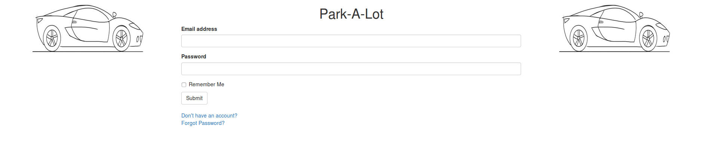

The user is presented with the form for new account creation. They must enter their first and last name, email address, password, password confirmation, zip-code and account type before submitting the form.

**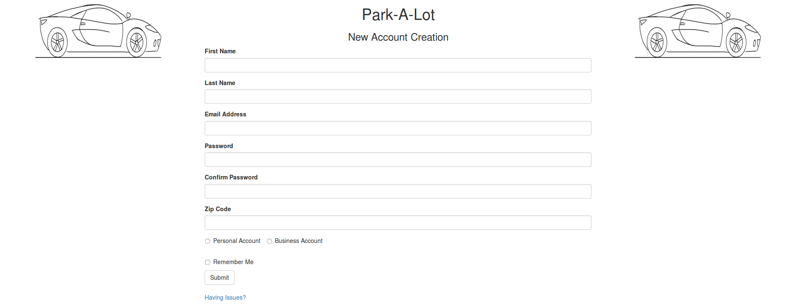**

The user is brought to the home screen where they can select “Current Vehicles” or “Current Payment Methods”.

**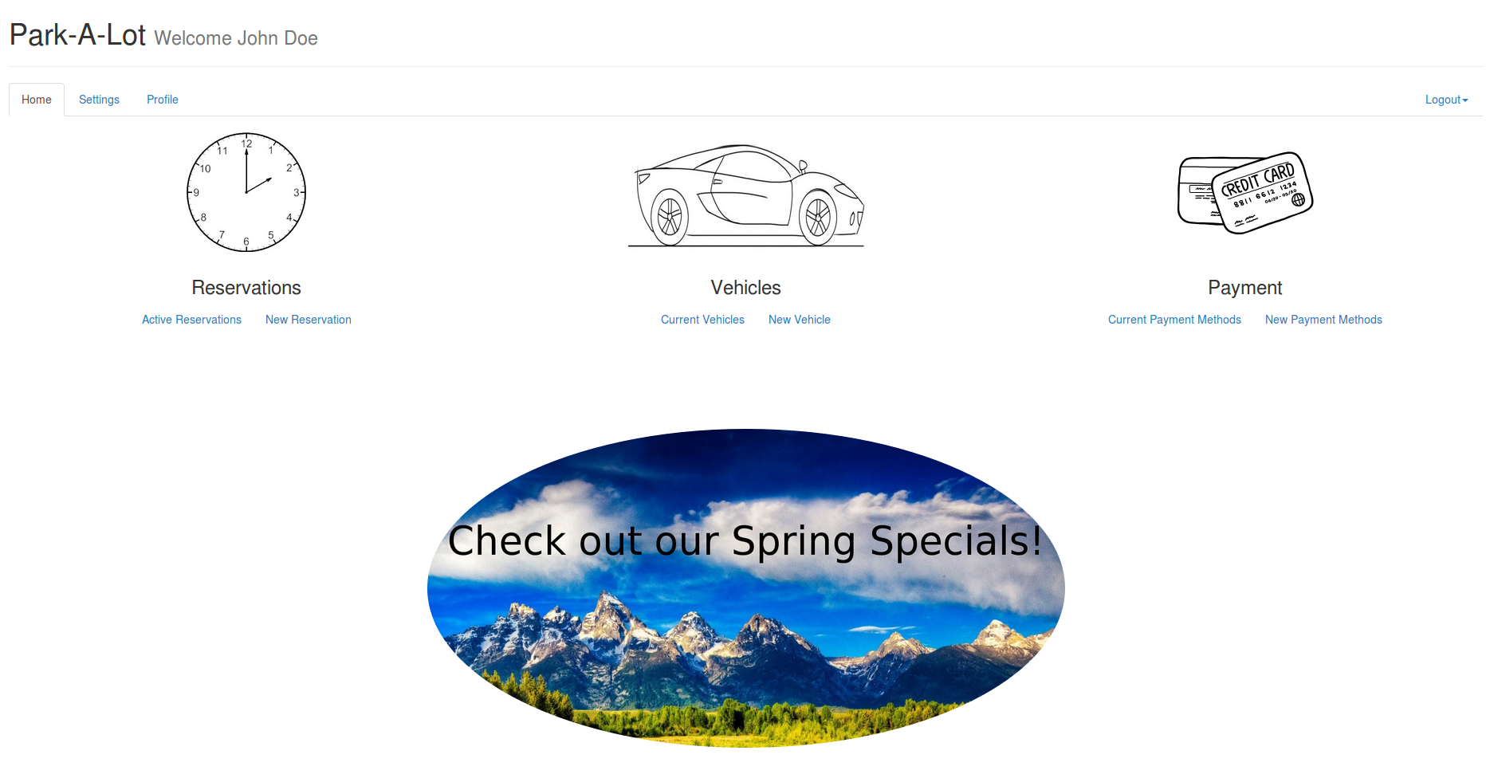**

Selecting “Current Vehicles” brings the user to the vehicle management screen where they can edit existing vehicles or add a new vehicle with the form on the right.

Selecting “Current Payment Methods” brings the user to the payment management screen where they can edit existing methods or add new payment methods with the form on the right.

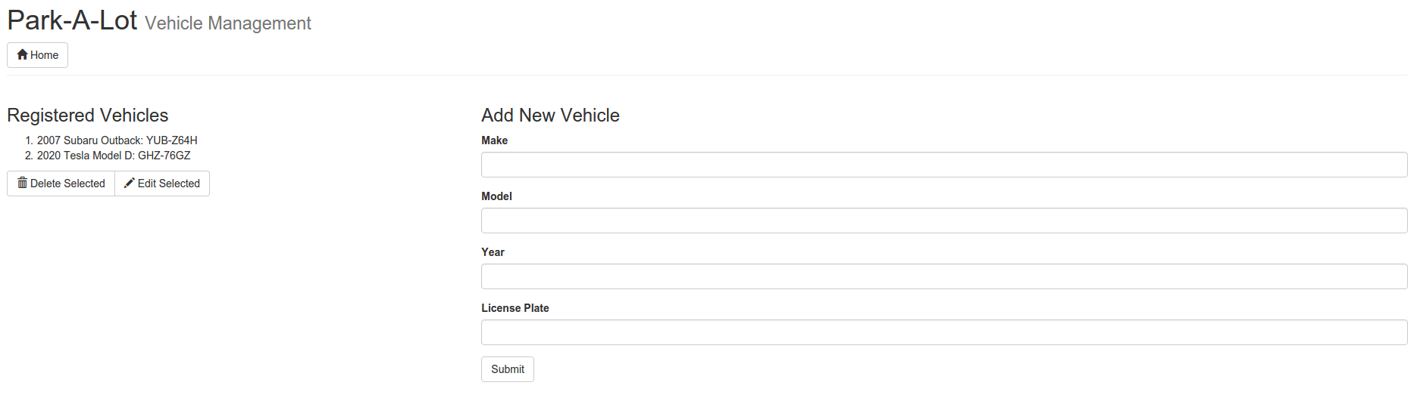

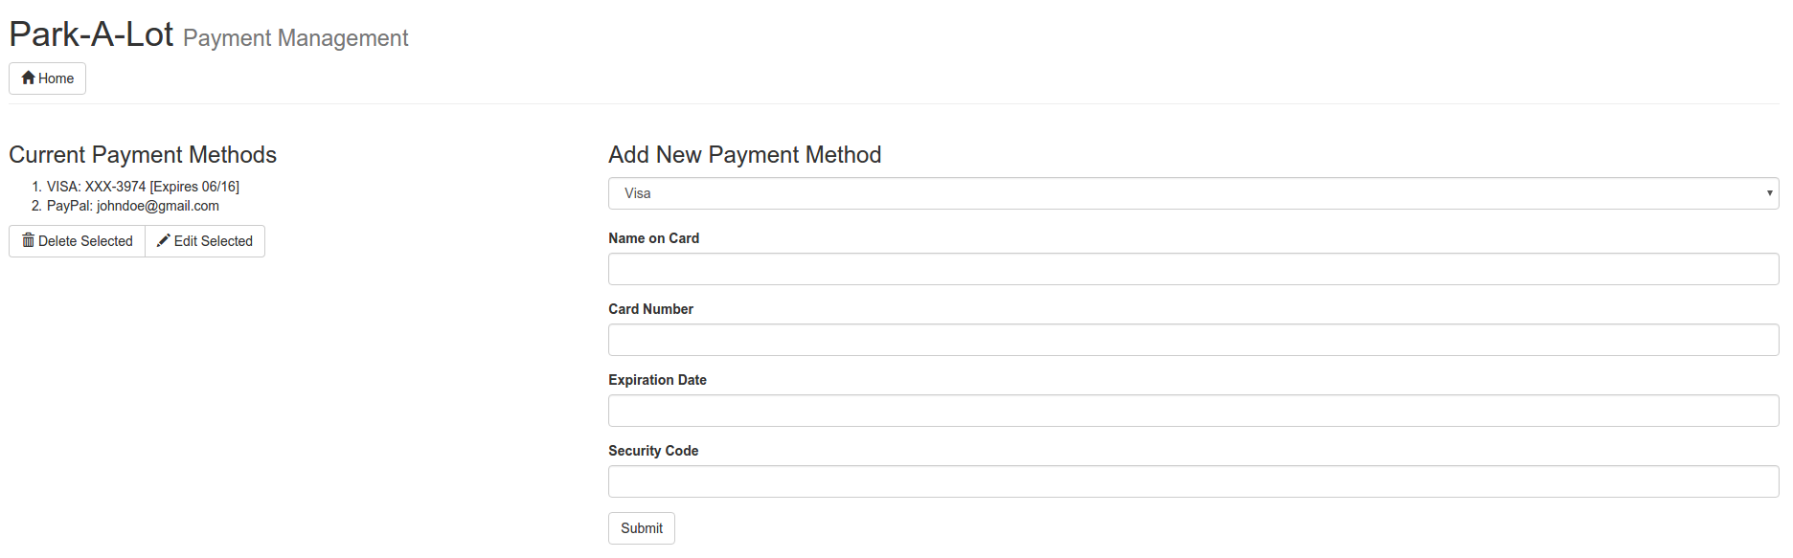

Use Case 2

The user will access [www.galuwa.com](http://www.galuwa.com) and use their email & account password to log in



The user is brought to the account home screen where they are presented with several quick options. Account settings and profile information can be accessed through the navigation bar. Specials are displayed towards the bottom of the page.

****

Clicking on New Reservation will bring the User to a screen to select blocks of time with their cursor. This calendar will display when the garage is full and available. This screen will list selected times, an estimated cost and any savings the customer is receiving. The selected payment method will be shown.

**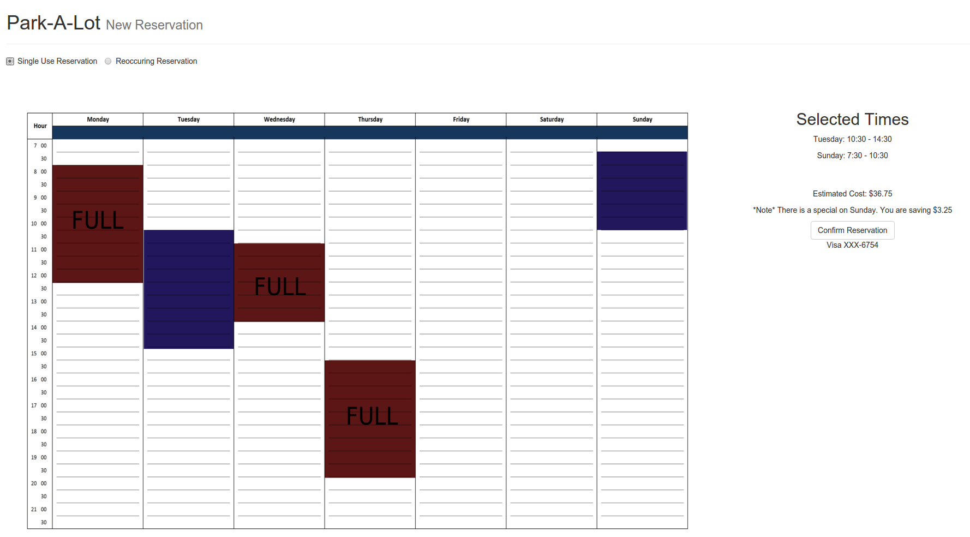**

The user will receive a confirmation notification from the system once they makes a reservation, listing the details of the reservation such as the date and time.

**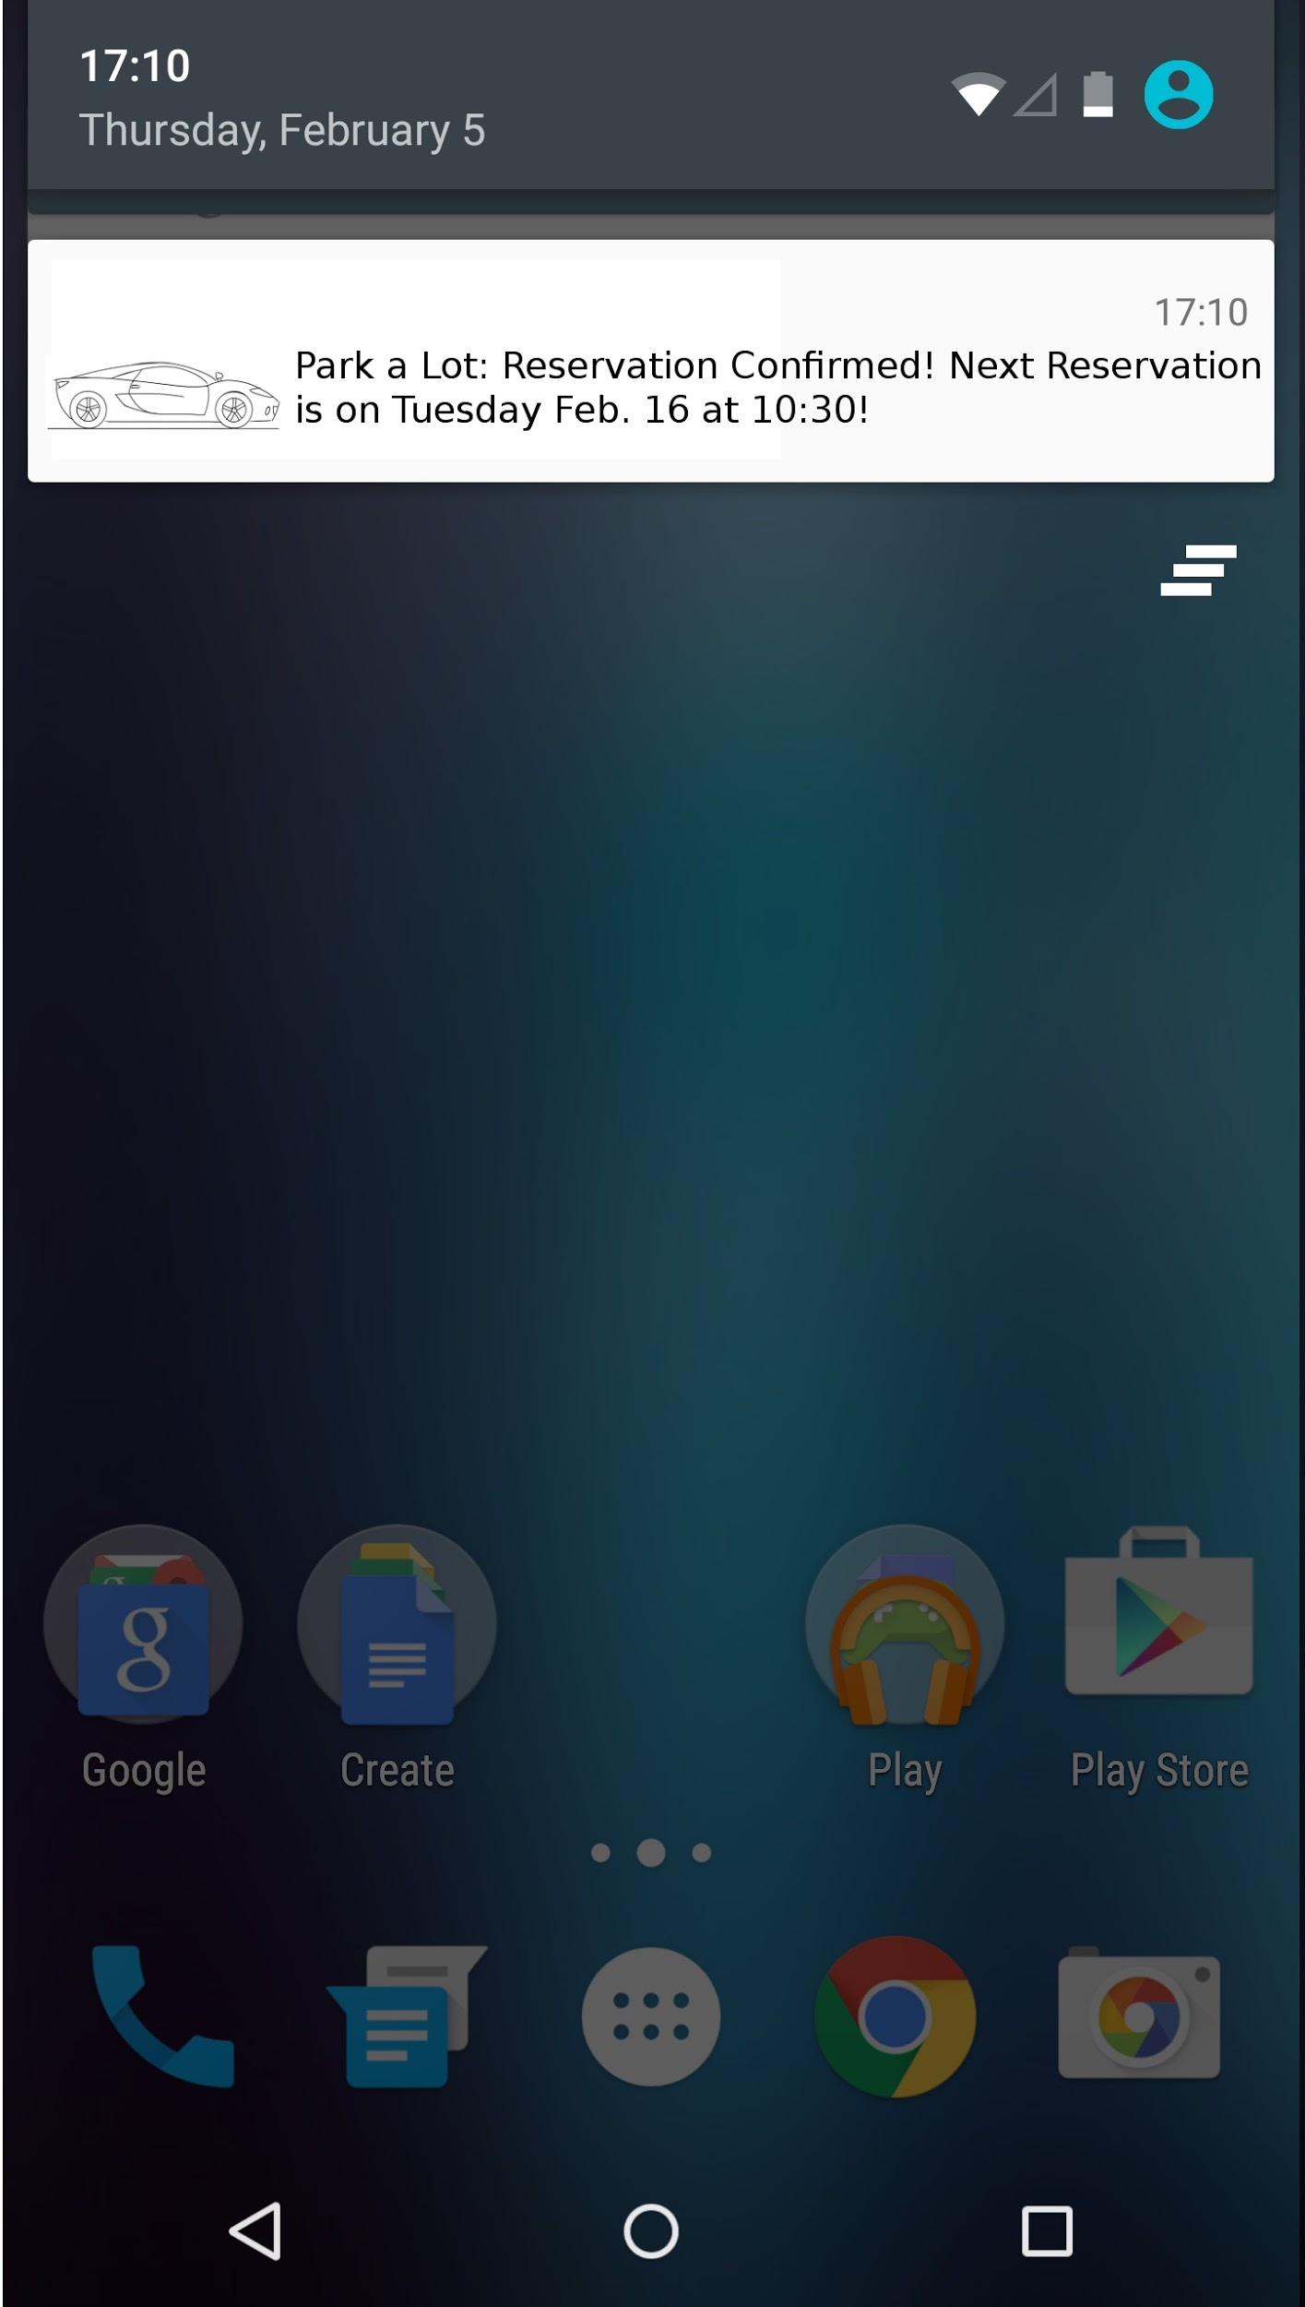**

Use Case 7

The manager will access [www.galuwa.com](http://www.galuwa.com) and use their email & account password to log in.



The manager is brought to the home screen where they are able to select between option categories. To change scheduling/rate options, the manager can select “Set Rates” and “Specials”.

**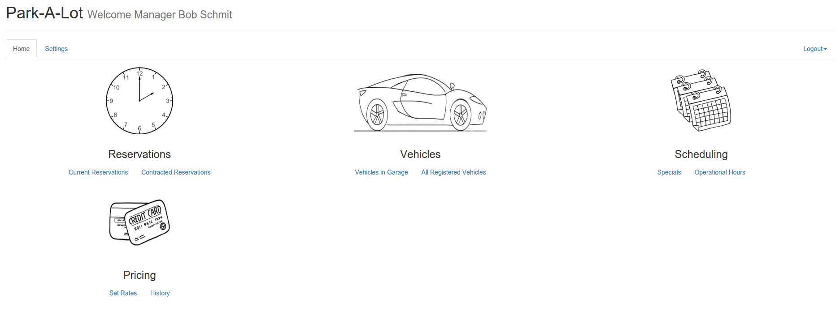**

From the Active Rate screen, the manager can edit/delete existing rules and add new rules to determine the garage pricing.

**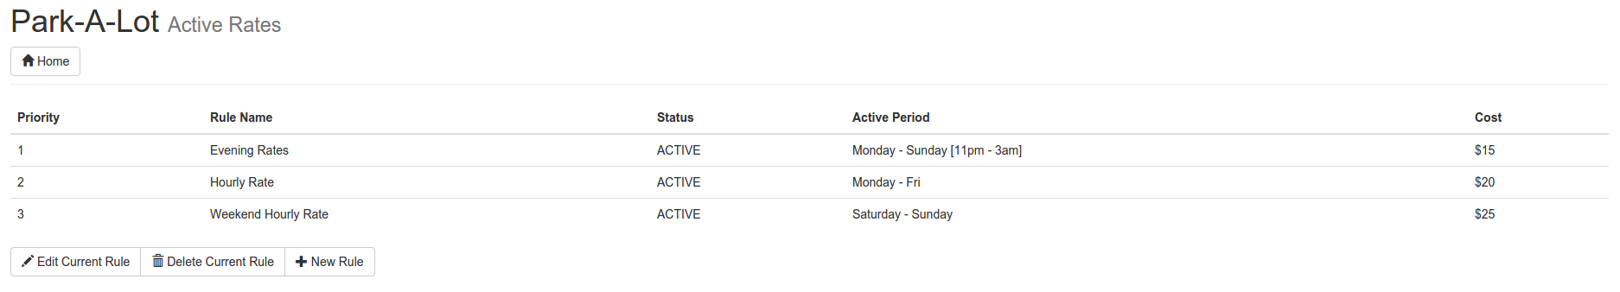**

**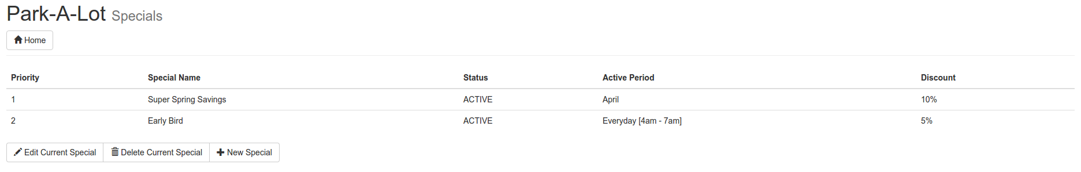**

**User Effort Estimation**

The website and console user interfaces have a few options:

For registration purposes, the website will require 1 stroke to click the “don’t have an account?” link and about 5-10 strokes for the first name and 5-10 for the last name. The e-mail address space will require an average of 15-20 strokes. It will take approximately 5 strokes for the zip code. The last few steps for registration shall take about 2-3 strokes, 1 for marking the type of account, 1 for the submit button, and possibly 1 for the “remember me” button if the user wants to.

The user will also enter his vehicle information into the website. The user interface minimizes this effort as well. It will take about 15-20 strokes for the make and model, 4 strokes for the year, and 6 strokes for the license plate number.

The user is able to enter the payment management screen by on click on the “payment method” icon. It takes only one click to choose payment method, such as visa, master and paypal.The credit card info space will require 16 strokes for card number , an average of 10-20 stroke for card holder’s name, 6 strokes for expiration date and 3 strokes for security code.

To make a reservation, it will require an average of 10 strokes for the username and 8-12 for the password for the login information plus 1 stroke for clicking the login button. 1 stroke will be used for press “make a reservation” and 1 more for selecting the time slot. After that it will take 1 stroke to select a saved payment method and 1 more to confirm. Making a reservation takes about 5 strokes after logging in.

The garage console user interface will require on average 11 strokes if the user wishes to type in the confirmation number manually and 2 strokes for the QR option, if the license plate cannot be read.

To access an active reservation, it requires an average of 18-22 strokes for username and password and 1 click of login button. And finally one click for the active button under the reservation category.

To cancel a reservation,it requires an average of 18-22 strokes for username and password and 1 click of login button. Then it requires one stroke to choose reservation, one stroke to choose “cancel reservation” button, and one stroke for “confirm cancellation”.

The manager will be allow to log into a special manager’s account, which allows users to change scheduling and rate, check out all reservations and vehicle information.

To check reservation detail and make changes as a manager, it will require an average of 10 strokes for the username and 8-12 for the password for the login information plus 1 stroke for clicking the login button, and one click on the “current reservation” or “contract information” under Reservation category. Then select a reservation by one click on it.

To change the current rule as a manager, after logging in, one stroke will be used to for pressing “Set rate” under Pricing category, one stroke to choose among “edit current rule”,”delete current rule” and “adding new rule”.

**Mathematical Model**

This software package will feature the ability to simulate the reservations, arrivals, and departures going through the garage. This simulation of artificial customers will be done using 2 Poisson processes. One of the Poisson processes is for the number of reservations being made, and the other process is for the number of walk-in customers that arrive. For a Poisson process with an average arrival rate , the probability of seeing arrivals in time interval t is:

****

The interarrival times are defined by the exponential distribution:



This simulation will assume that a customer will not make a reservation more than 24 hours in advance of their desired arrival time, and no less than 1 hour before. If reserved parking is booked the customer will attempt to make a reservation for 5 minutes later, and will continue until they get a reservation. We will assume that any customers that made a reservation will arrive to the garage on time. Reserve customers that made a reservation for the same time will be randomly entered into a queue to enter garage. Upon arrival, both walk-in and reserve customers will be assumed to enter the garage and park in optimal time. So the time it will take for a customer at the front of the queue to park T, will be:



Where c is the time to check in at the front console (it should take slightly longer for walk-in customers), e is the time for the elevator to lift the customer, this will be 0 for walk-in customers, and p is the time to park. When the customer checks in, they are assigned the available parking space closest to the exit. We are assuming the entrance and exit are as far apart as possible, this way cars parking at the same time should never cross paths or get in each other’s way . The simulation will know the shortest route to any park for a distance of *d*, and will assume the customers will always move at the garage’s speed limit *s*. When dealing with a queue to enter the walk-in floor, the next car begins their check in process as soon as the car in front finishes theirs. So if a walk-in customer is ith in line, the time it will take for them to park is:



This simulation will assume that a customer will not enter the line if it will not be possible to park by the time they make it to the front of the queue. For the reserve customers they will start their check in process after the car in front finishes their check-in process, takes the elevator up, and the elevator comes down. So if a reserve customer that is ith in line will take:



Departure from the garage will be based on the reservation the customer made. This simulation will assume that customers will make a reservation of at least 10 minutes, and at most 9 hours, and will set the end of their reservation to be at a 5 minute interval of real time. In other words a customer would set the end for their reservation at 12:00 or 12:05, but would not set it at 12:02 or 12:07.

The simulation will act on the assumption that the closer it is time for a reservation will end, the more likely the customer is to depart. However this simulation will assume that customers will not depart for at least 5 minutes after parking. The probability that a given customer will depart at any given second is:



Where is the total time of the reservation in seconds, and is the seconds since the customer parked.

**Project Management**

Team members:

1) Brandon Dunlap <brandon.dunlap@rutgers.edu>

2) Vikram Krishna <vk235@rutgers.edu>

3) Yufeng Liu <yufeng.liu@rutgers.edu>

4) Luke Miller <luke.miller@rutgers.edu>

5) Harshil Patel <harshil1029@gmail.com>

6) Thomas Walters <twalters1012@gmail.com>

7) Xiang Xing [<xx52@scarletmail.rutgers.edu>](about:blank)

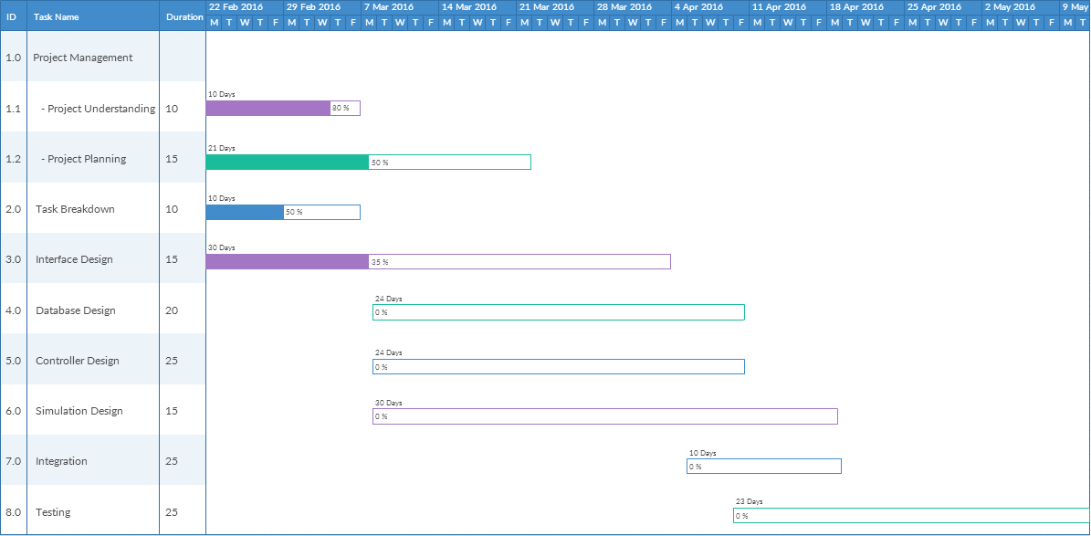

This GANTT Chart is used to map our future design, development and testing in an easy to read manner. We have estimated how much time each task will take and specified an estimated start/end date for each section. Although this will change over time, this gives us insight on when our relative deadlines are.

These trees break up most of our coding design work into management and customer use categories. It has been designed so that there is a child section to be assigned to each team member.

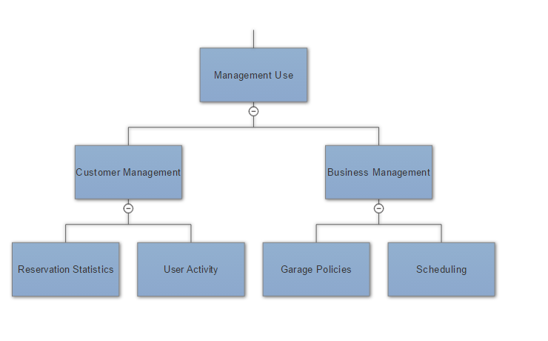

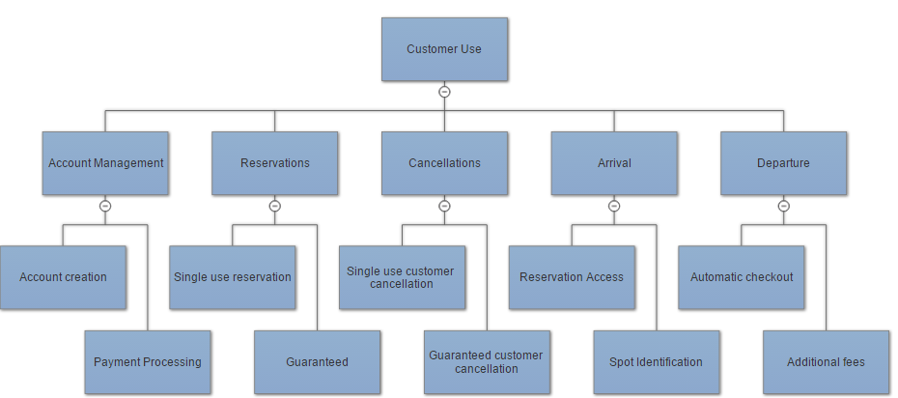

Breakdown of responsibilities

|  |  |
| --- | --- |
| Group Member Name | Luke Miller |
| Work Done So Far | Responsible for team organization and communication. Coding wise, I developed a bootstrap framework for the project website which we can build on. I have been submitting the projects after organizing, editing and verifying that each report adheres to the requirements. |
| Future Work | I will continue to facilitate the division of work to ensure that everyone contributes evenly and meets deadlines. Coding wise, I will be developing the **User Reservation** aspect of the Park-A-Lot system. |

|  |  |
| --- | --- |
| Group Member Name | Harshil Patel |
| Work Done So Far | Completing parts of the report assigned to me and formatting and proofreading the report before submission. Assisting Luke in team organization and communication. |
| Future Work | I will assist in the future coding of different parts of the system as I see capable of doing based on my skillset. Although my main focus will be doing more of the development aspect of the project and documentation. Will continue to help in team organization. |

|  |  |
| --- | --- |
| Group Member Name | Yufeng Liu |
| Work Done So Far | Completing the tasks assigned to me: this time is attribute definition. Helping to edit the report bases on team’s requirements and improve the incompleted part before the submission. |
| Future Work | My main focus is assisting my team in future coding part, for instance, the elevator part of the parking garage simulation. (The interaction between the garage system and customers.) |

|  |  |
| --- | --- |
| Group Member Name | Vikram Krishna |
| Work Done So Far | Completing the tasks assigned to me. I was assigned to do the concept pairs, i also helped iron out the concepts themselves. |
| Future Work | I will be focusing on the coding, and hopefully will be leading a small team in the parking spot portion of the code. How the customers spots are determined and how to minimize spot conflicts(no open spots left, or only for premium holders) |

|  |  |
| --- | --- |
| Group Member Name | Xing Xiang |
| Work Done So Far | Completing the tasks assigned to me. This time I have done the Plan of Work Part |
| Future Work | I will work on both coding and documentation part, and trying to find Group member who need help. I prefer working on the Management part. |

|  |  |
| --- | --- |
| Group Member Name | Thomas Walters |
| Work Done So Far | Completing tasks assigned to me, which included editing/proofreading, facilitating in communication and for this last part specifically it was concept definitions. |
| Future Work | I will continue to help in communication and complete any assigned tasks that we decide in our weekly meetings. Any future work may include coding, documentation, or project management. |

|  |  |
| --- | --- |
| Group Member Name | Brandon Dunlap |
| Work Done So Far | Completing tasks assigned to me, which included Mathematical Modeling. |
| Future Work | I will continue to refine and edit the models in addition to helping with the algorithms to determine space availability. |

**References**

Freeman, Eric, Elisabeth Robson, Kathy Sierra, and Bert Bates. *Head First Design Patterns*. Sebastopol, CA: O'Reilly, 2004. Print.

Marsic, Ivan. "Software Engineering Project Report." *- Requirements*. Web. 21 Feb. 2016.

Marsic, Ivan. "Software Engineering." *Ece.rutgers.edu*. Web.

Marsic, Ivan. "1. Project Description." *Software Engineering ProjectParking Garage/Lot*. Web. 21 Feb. 2016.

"Parking Garage." *Parking Garage*. Web. 21 Feb. 2016. <https://sites.google.com/site/parkinggaragesp13/home>.

Pilone, Dan, and Russ Miles. *Head First Software Development*. Sebastopol, CA: O'Reilly, 2008. Print.